Task 1: Creating a virtual network
Step 1: Filling in the basic details for creating a virtual network, name is set vnet1 and resource group is set to “NetworkWatcherRG”.
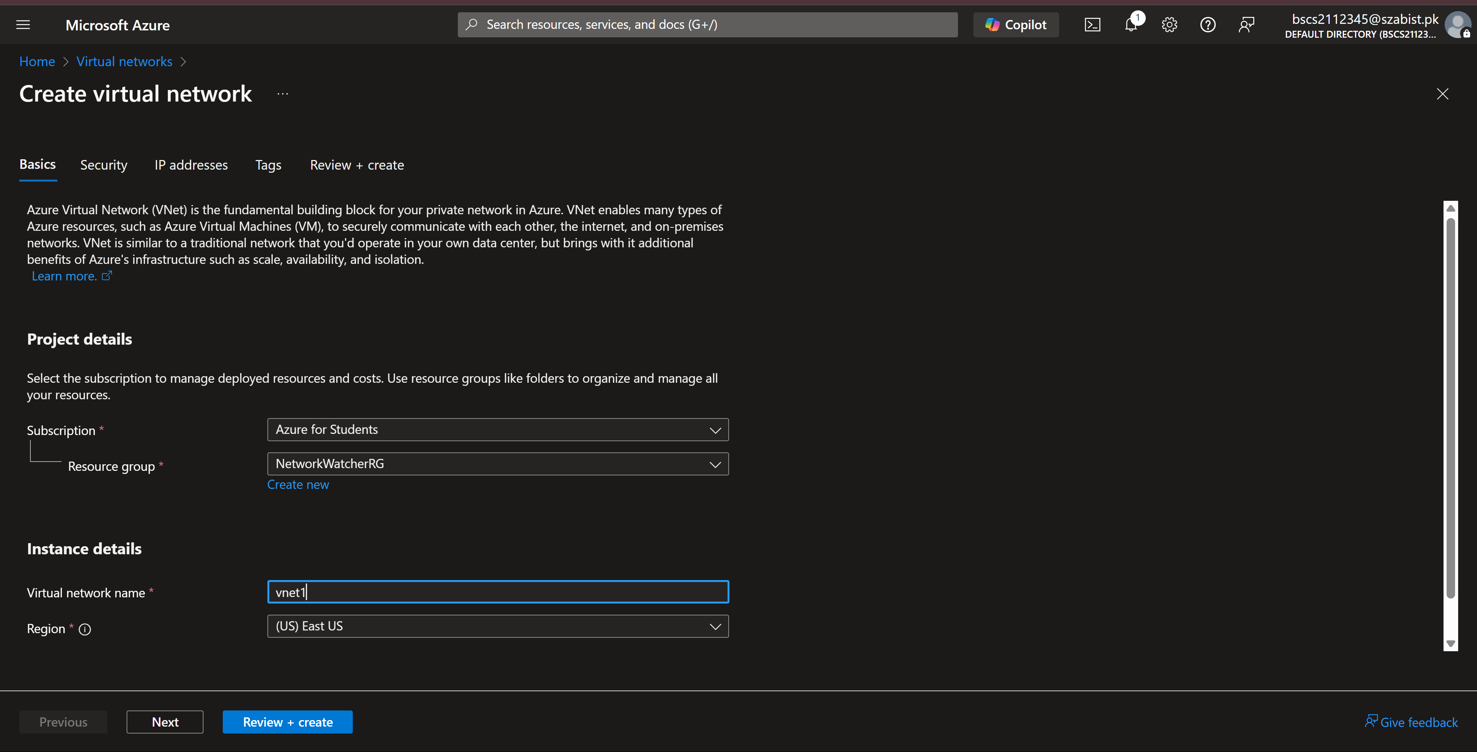
Step 2: The below screenshot displays that review of the configuration has passed. With this we create the virtual network by clicking on “Create”.
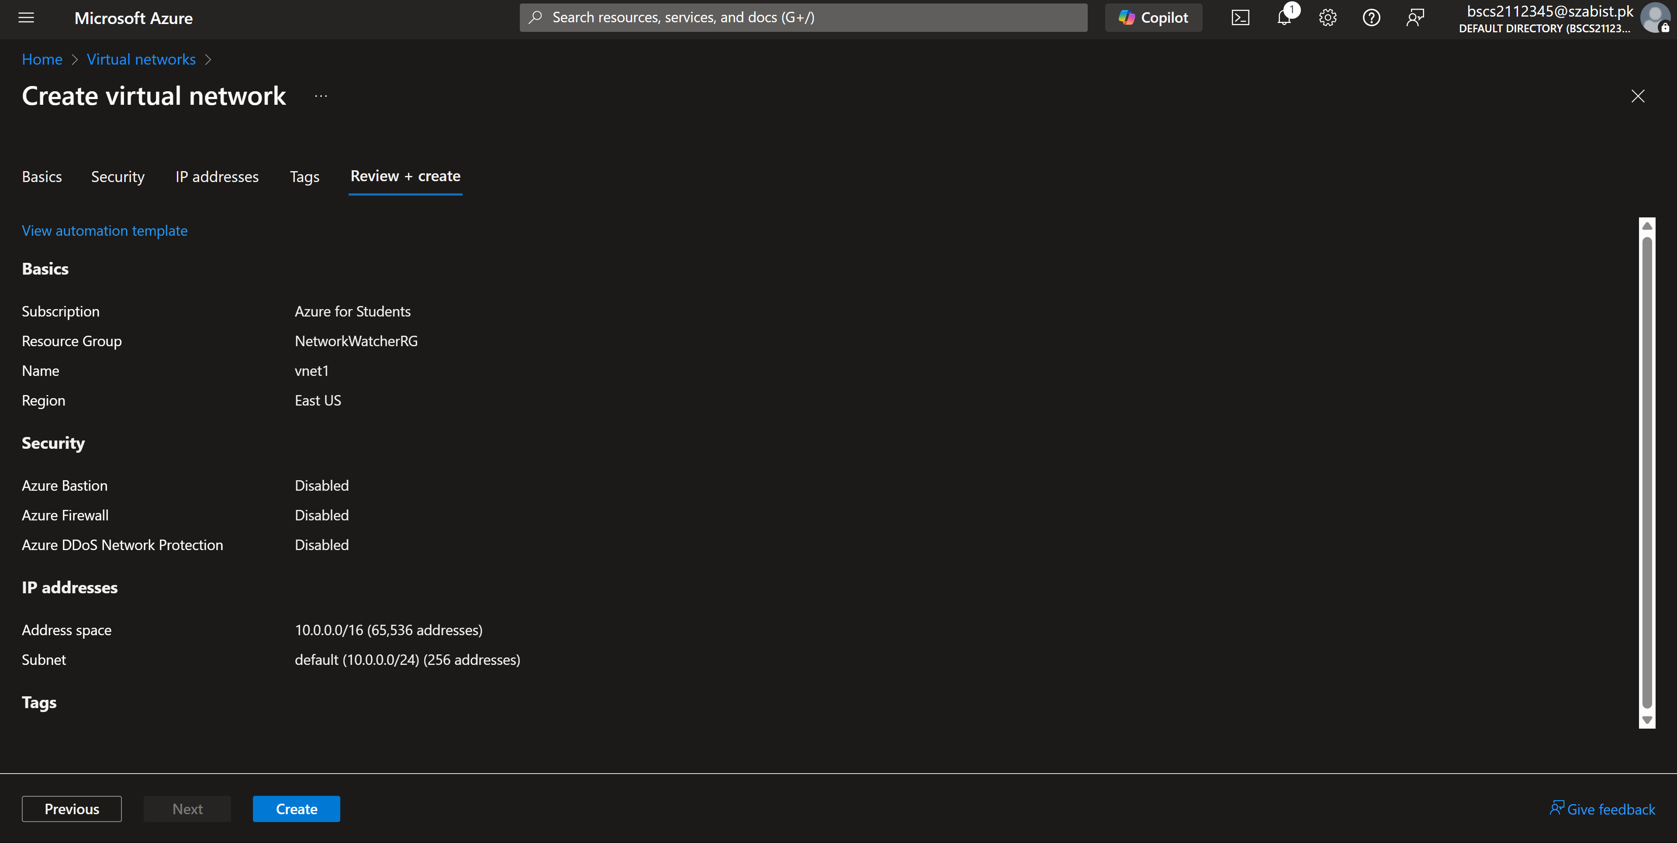

Task – 2: Create two virtual machines
Step 1: Completing basic details for VM-1
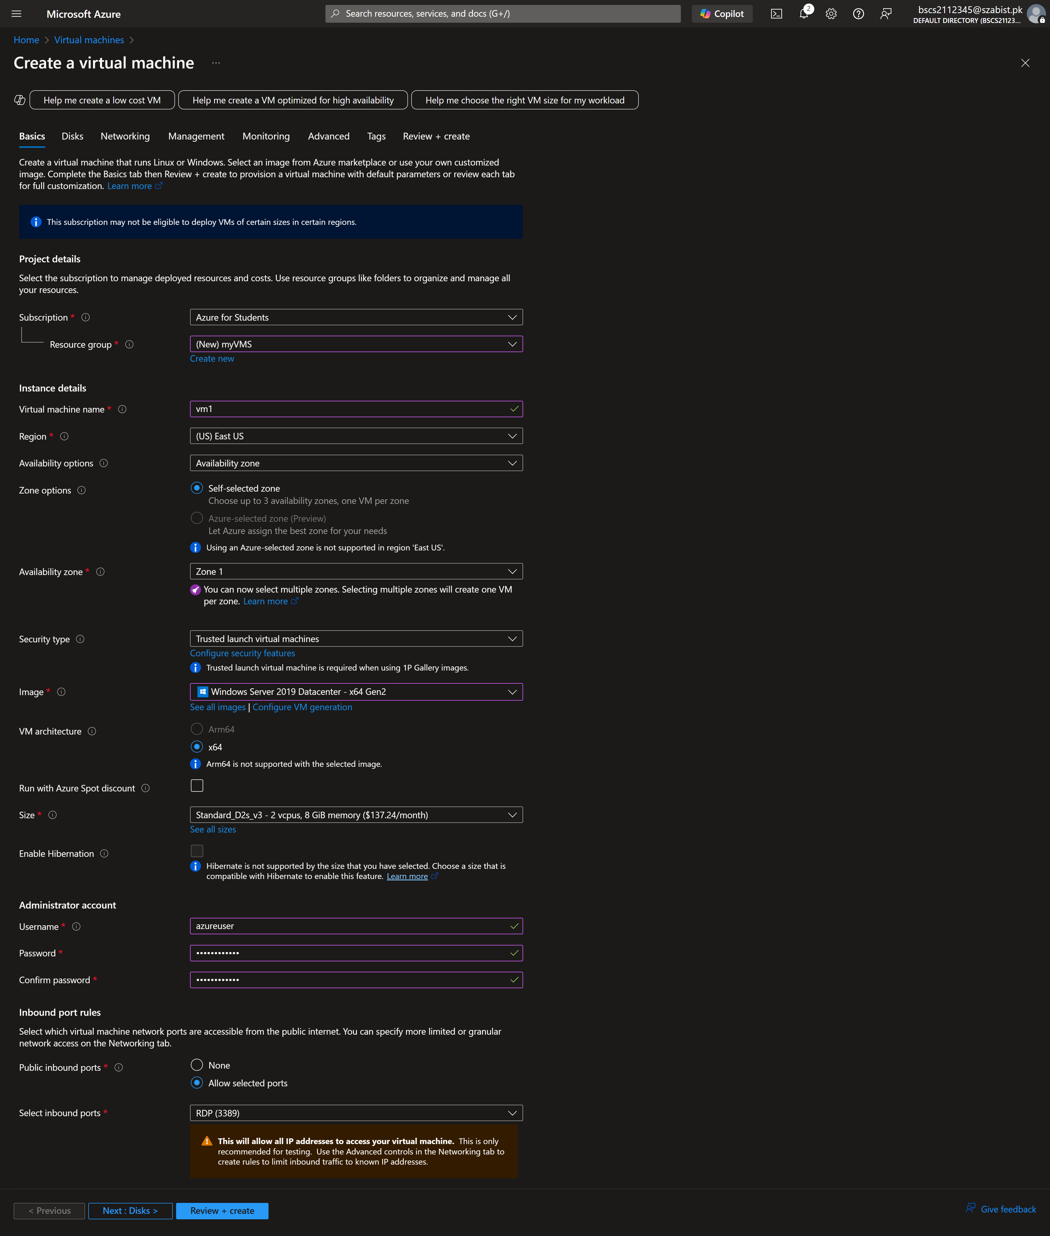

Step 2: Selecting the virtual network for VM-1 as “vnet1” the one which we created in Task 1.
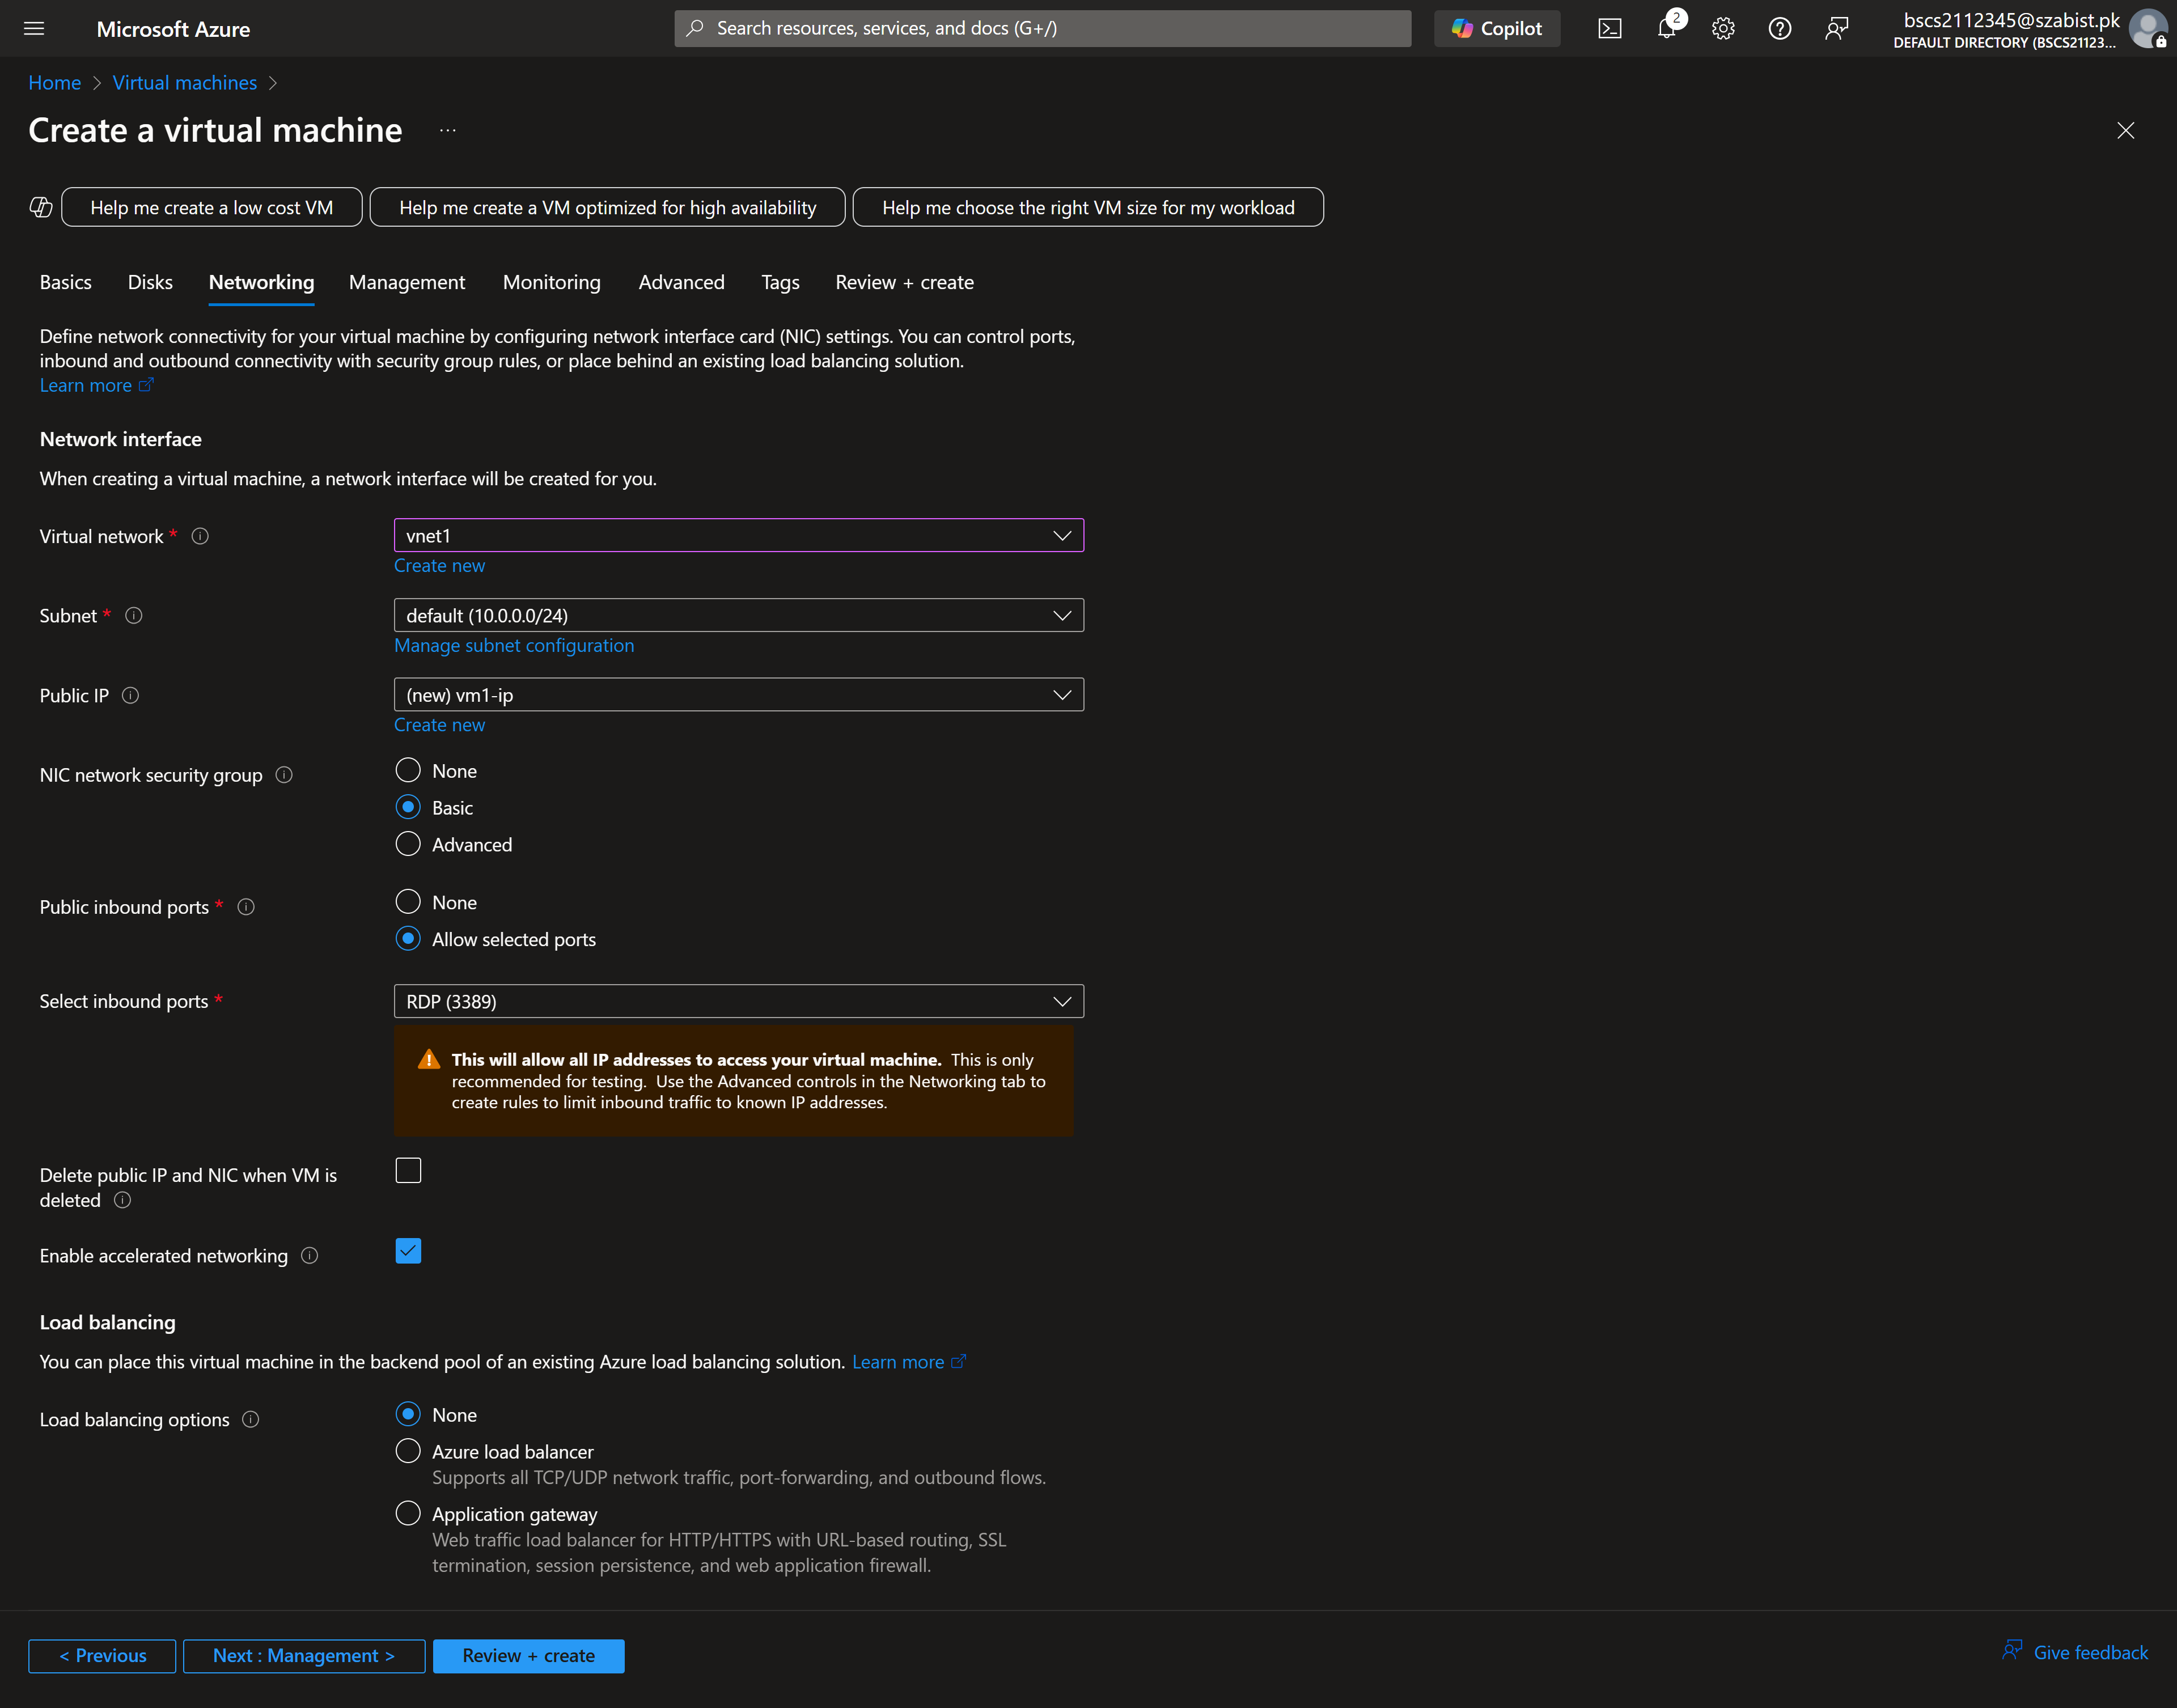

Step 3: The below screenshot highlights that all configuration have passed the validation test and the VM can be created.
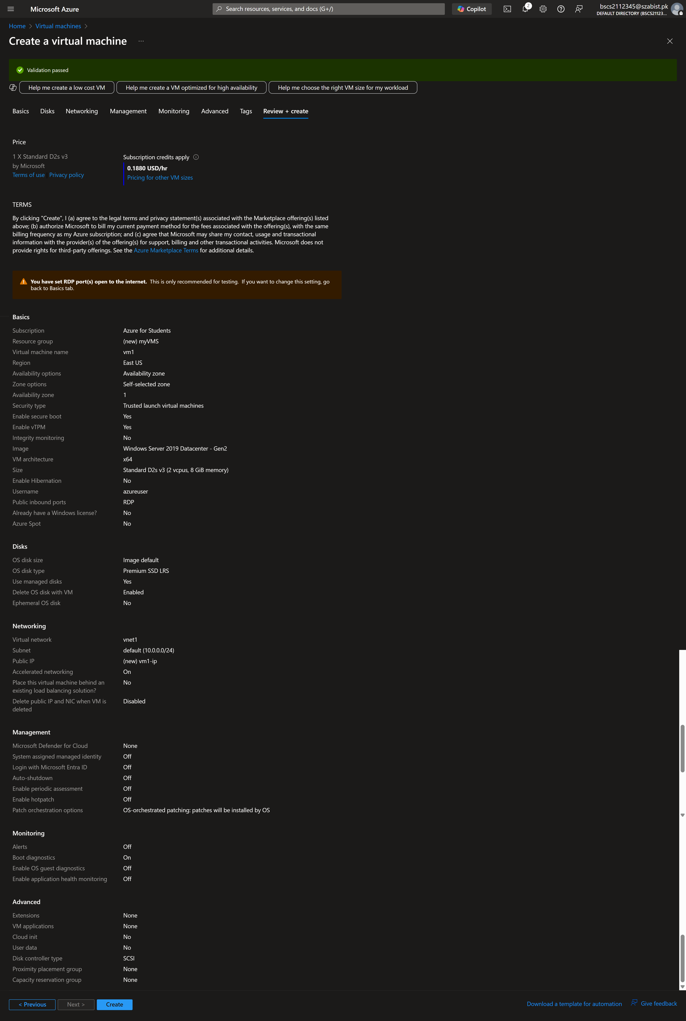
Step 4: Completing the basic details for VM-2
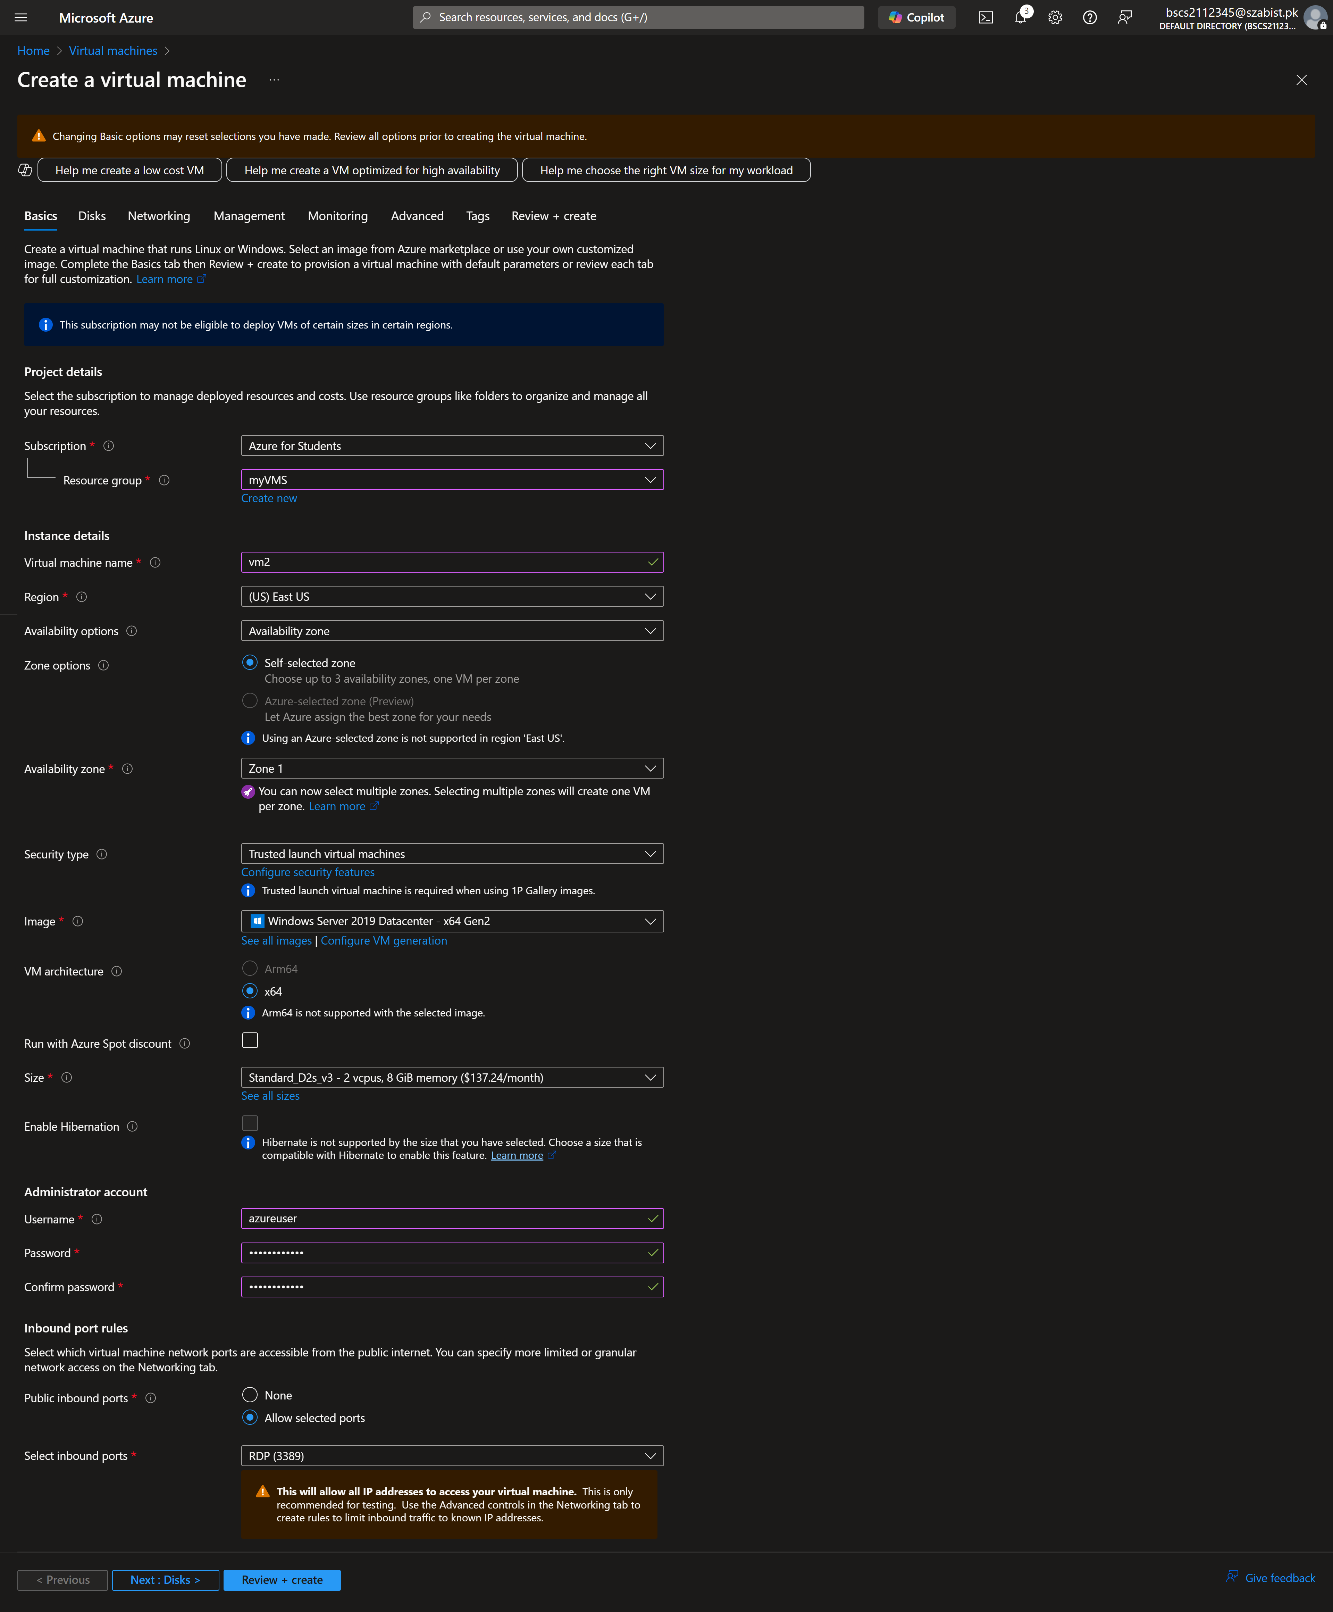

Step 5: Selecting “vnet1” as the virtual network for the VM-2. Proceeding this we finalize the configuration and create the VM.
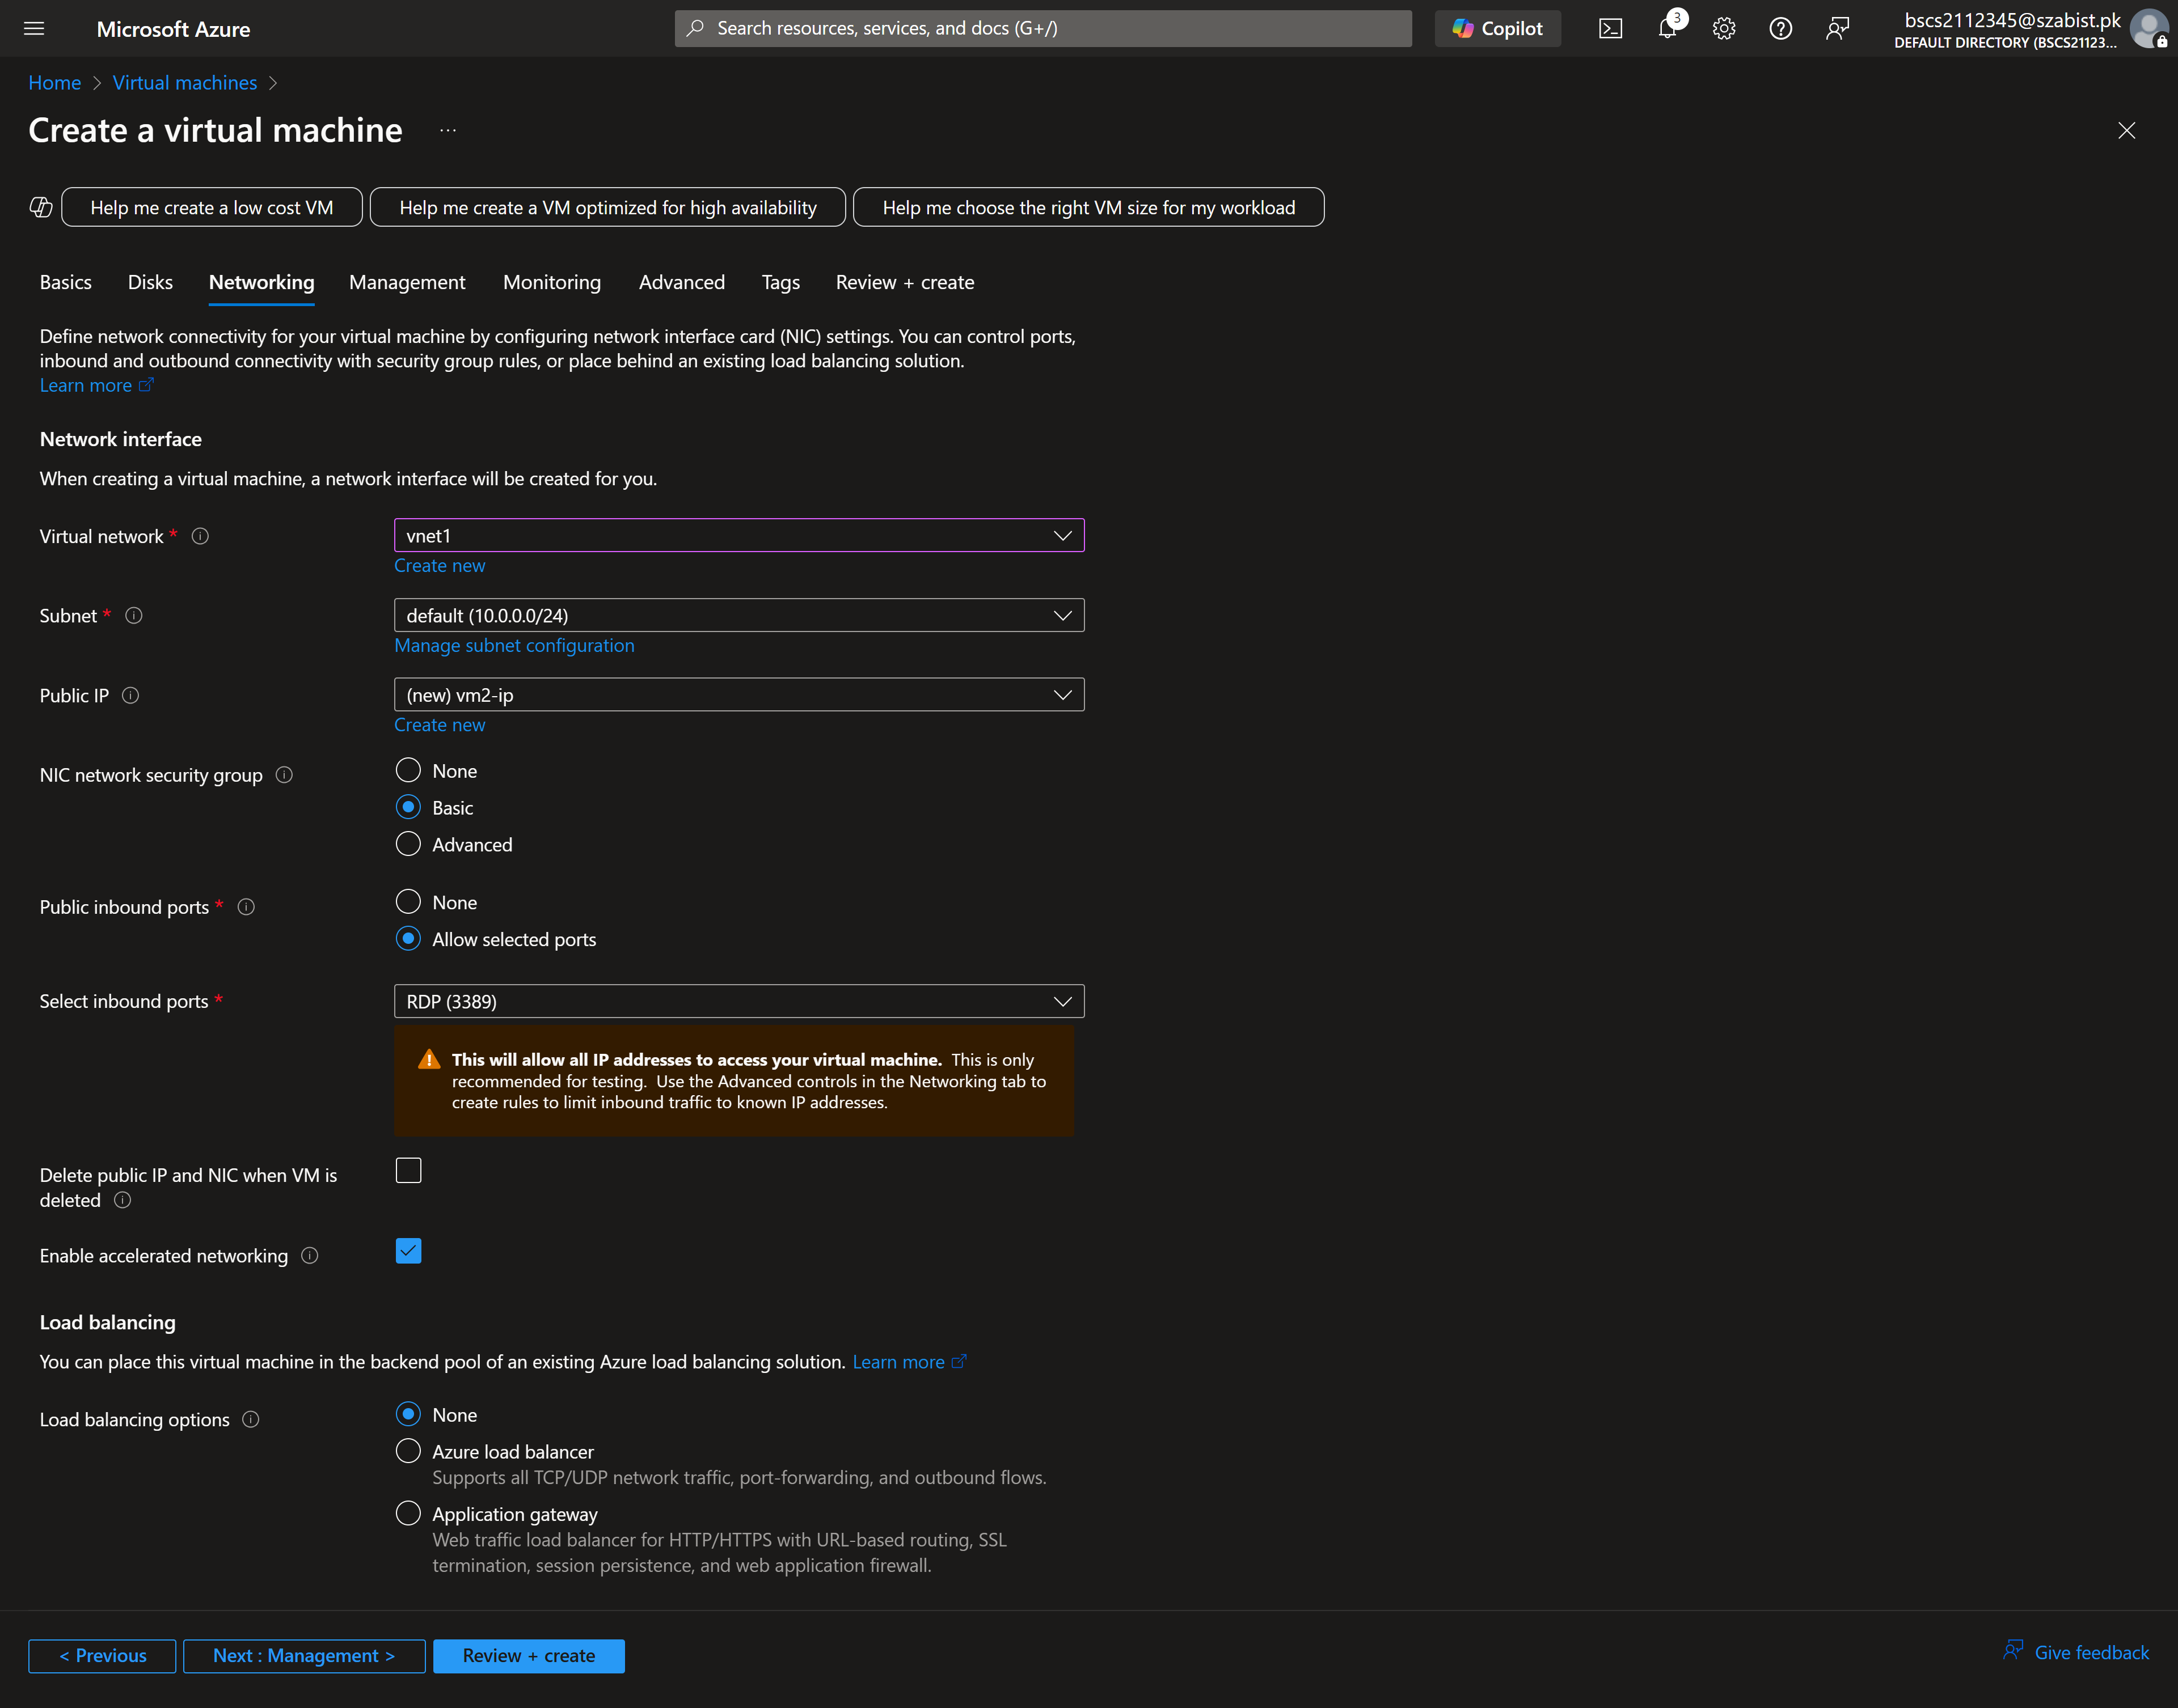
Step 6: Displays the list of virtual machines created with basic info such as status and IP
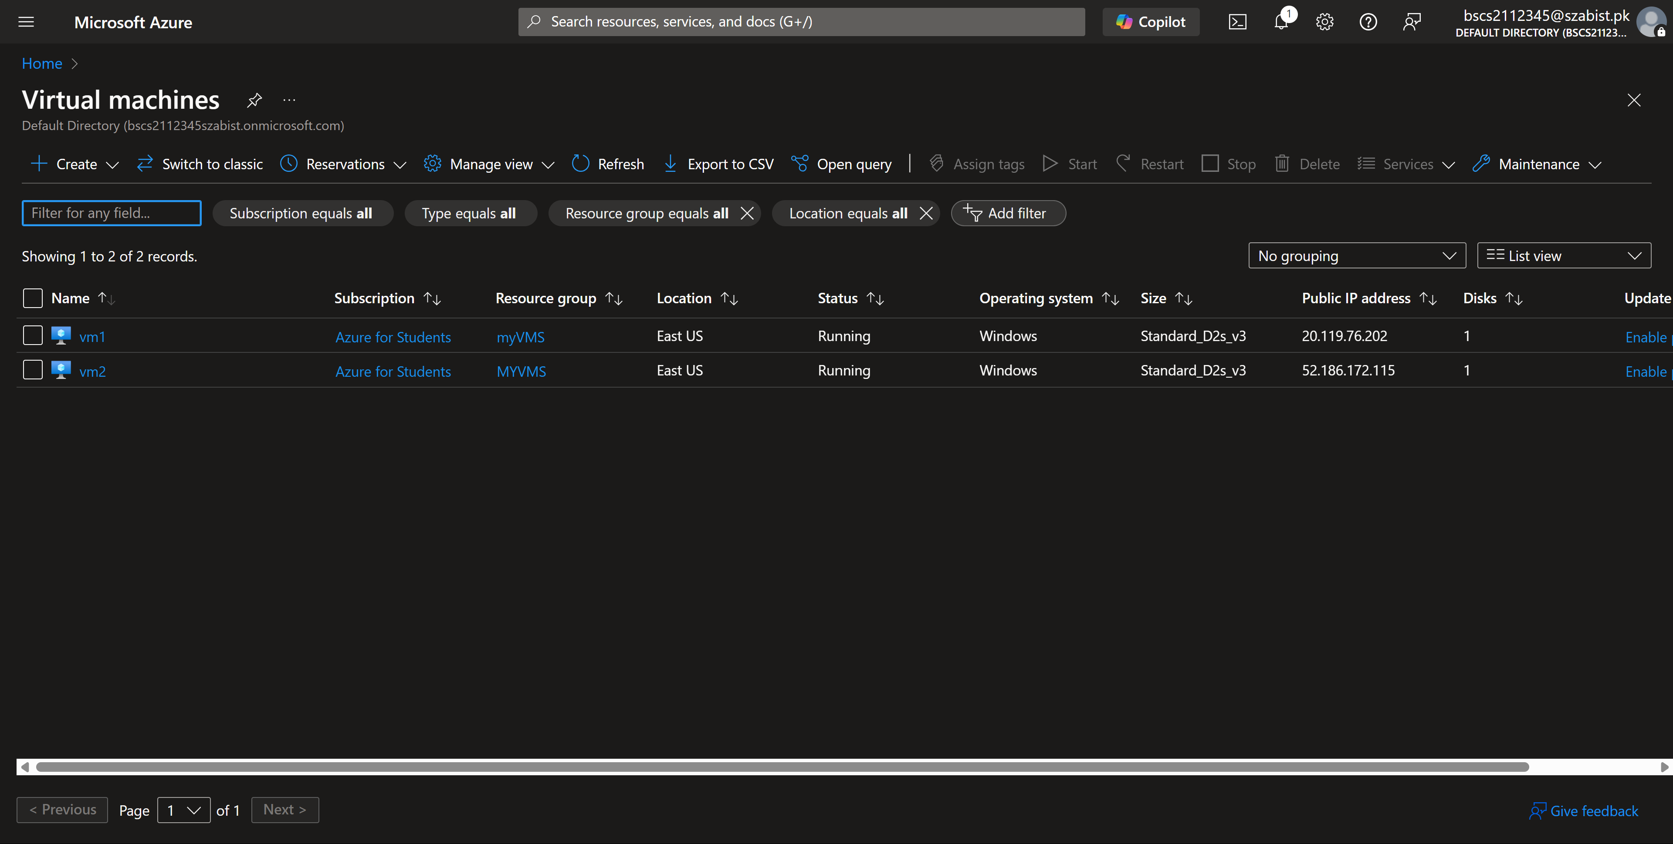
Task – 3: Testing the connection
Step 1: Downloading the RDP file for VM1 to access it.
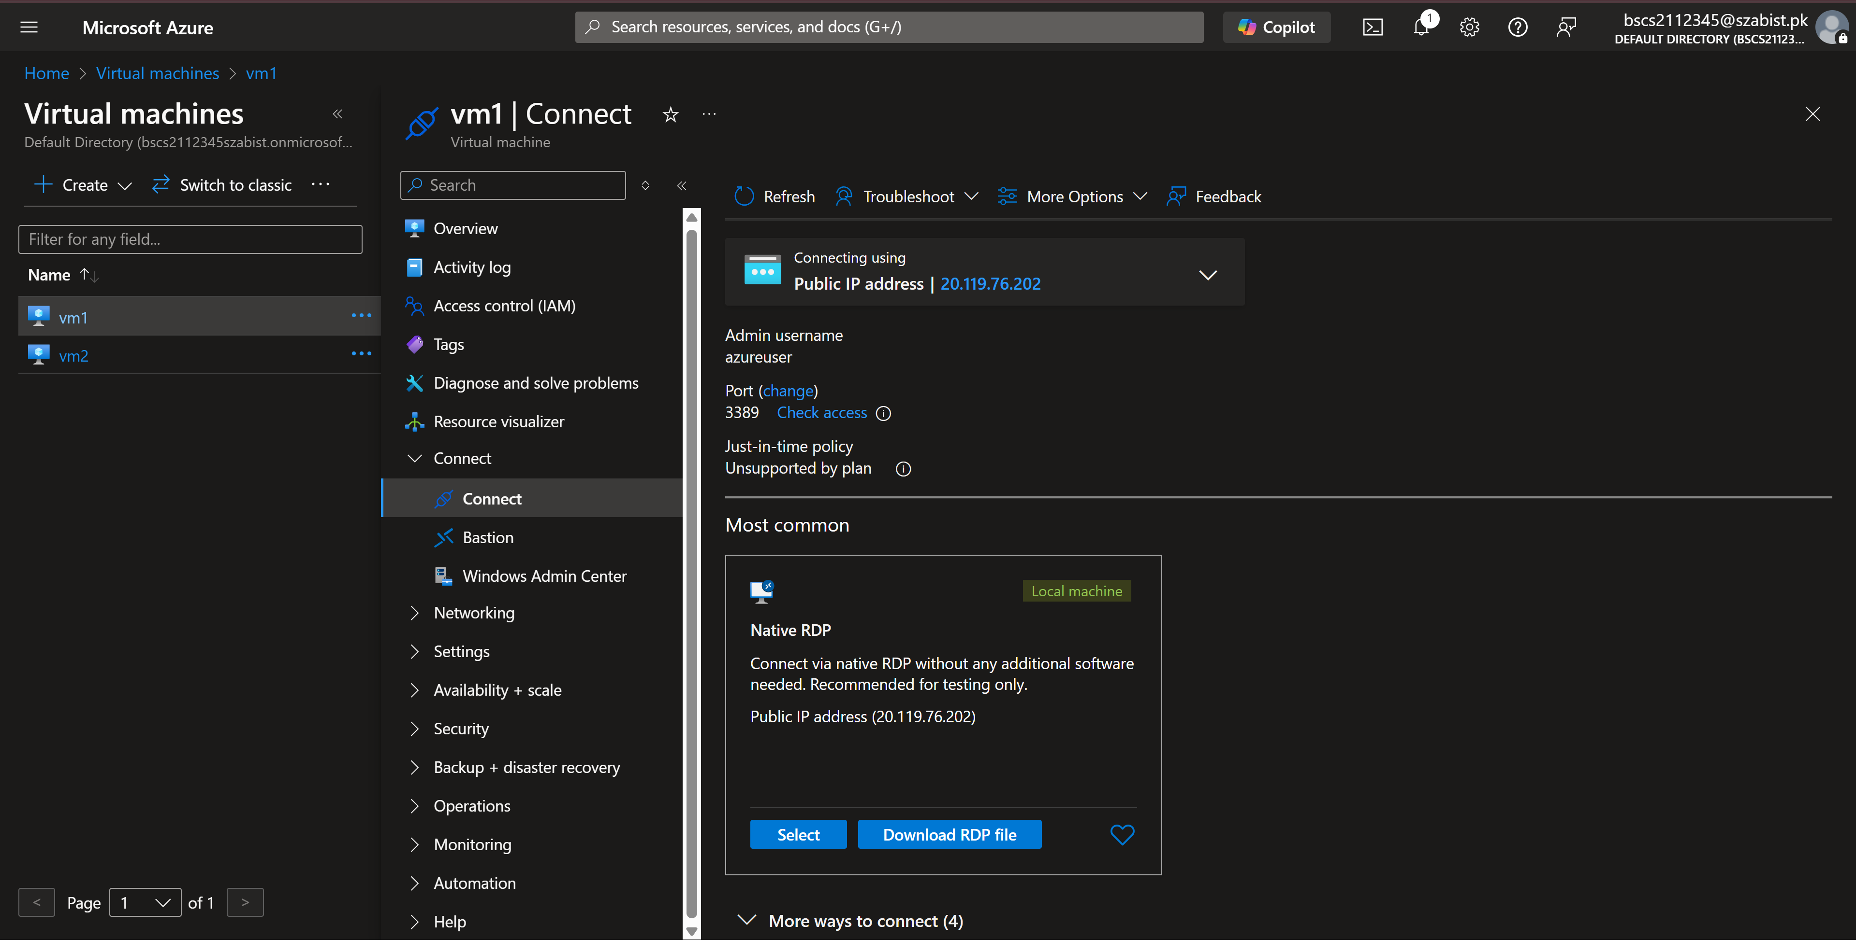
Step 2: Downloading the RDP file for VM2 to access it.
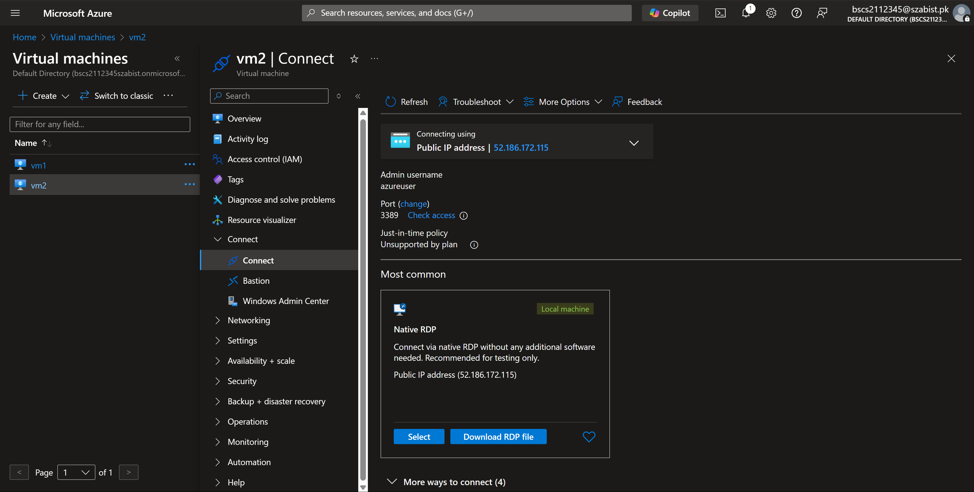

Step 3: After accessing VM1, the firewall has been disabled to test the connectivity
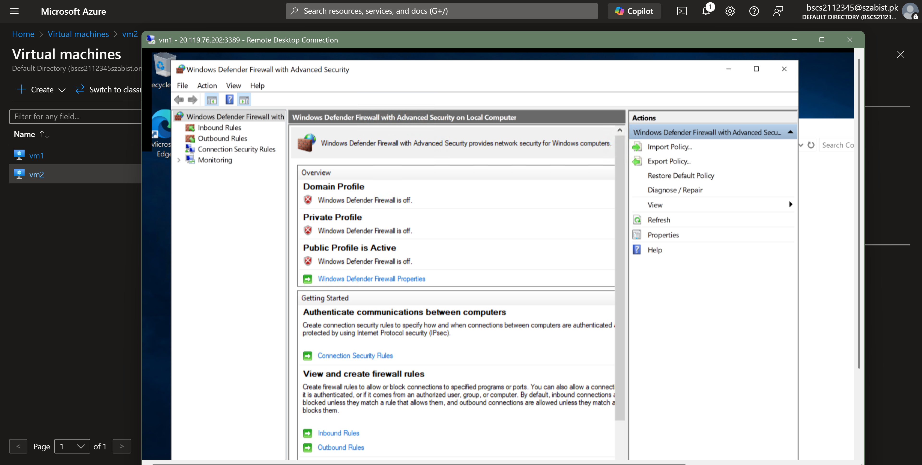
Step 4: After accessing VM2, the firewall has been disabled to test the connectivity
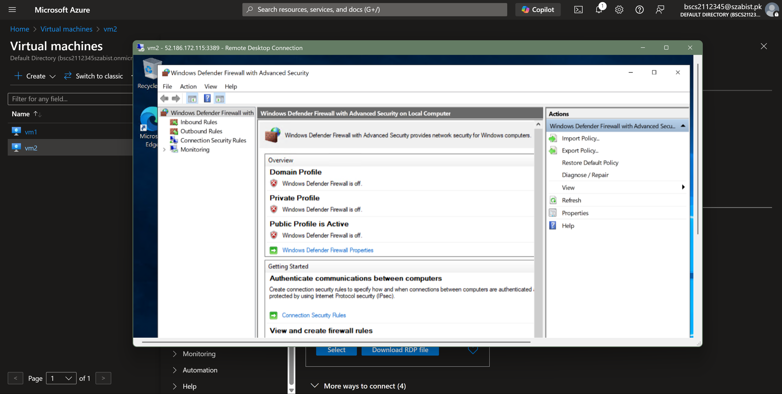

Step 5: Finally, the ping command is executed to test whether a connection is established
